With just one chord you can play…
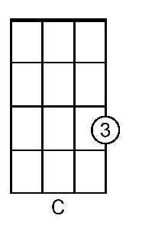
Are you sleeping, Are you sleeping
Brother John? Brother John?
Morning bells are ringing, Morning bells are ringing
Ding ding dong! Ding ding dong!

