Ukulele Diagram

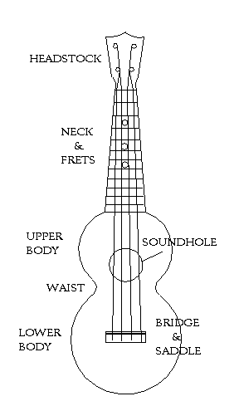
Try “Simon Says” with the parts of the ukulele

